First of all you should have java installed JDK installed open command line and check which version of JDK you are having by typing “javac –version” if you are not having JDK then install it from here latest version of JDK http://www.oracle.com/technetwork/java/javase/downloads/jdk8-downloads-2133151.html

On some Windows systems, the launcher script does not find where the JDK is installed. If you encounter this problem, you need to set an environment variable indicating the correct location.
Select Start menu > Computer > System Properties > Advanced System Properties. Then open Advanced tab > Environment Variables and add a new system variable JAVA_HOME that points to your JDK folder, for example C:\Program Files\Java\jdk1.7.0_79.

Now you should have android studio installed if you do not have android studio then you should install android studio https://developer.android.com/studio/install.html
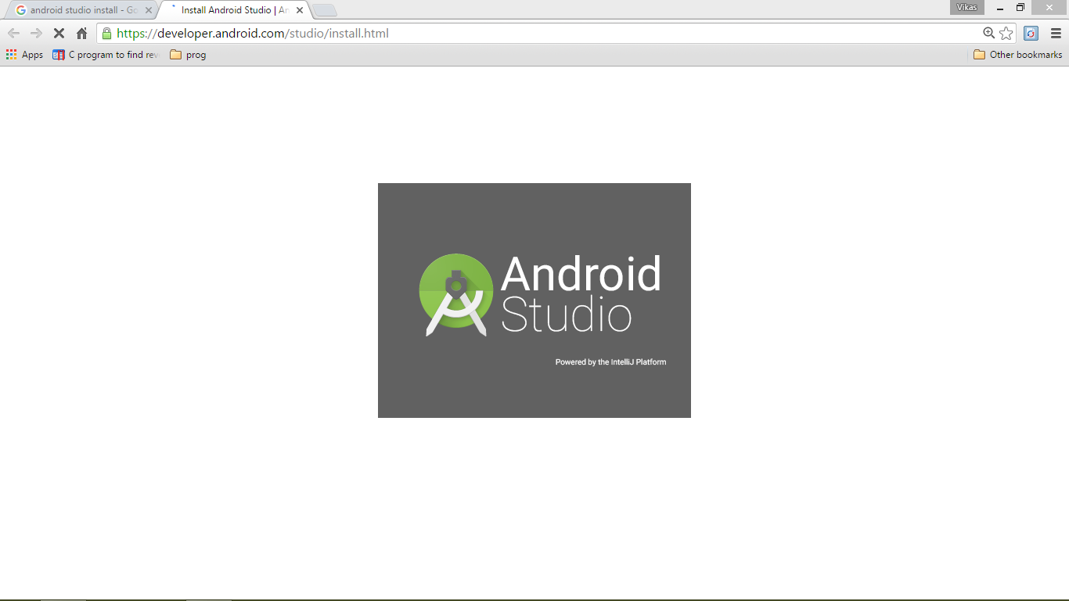
Before starting with importing code you must have git installed on your desktop https://git-scm.com/book/en/v2/Getting-Started-Installing-Git
After installing Android studio and git now I will be importing the ODK code from github.
First of all create an ODK directory(Folder) in the git bash
By typing the command mkdir ODK
Then type command ls
You will see an ODK Directory is made
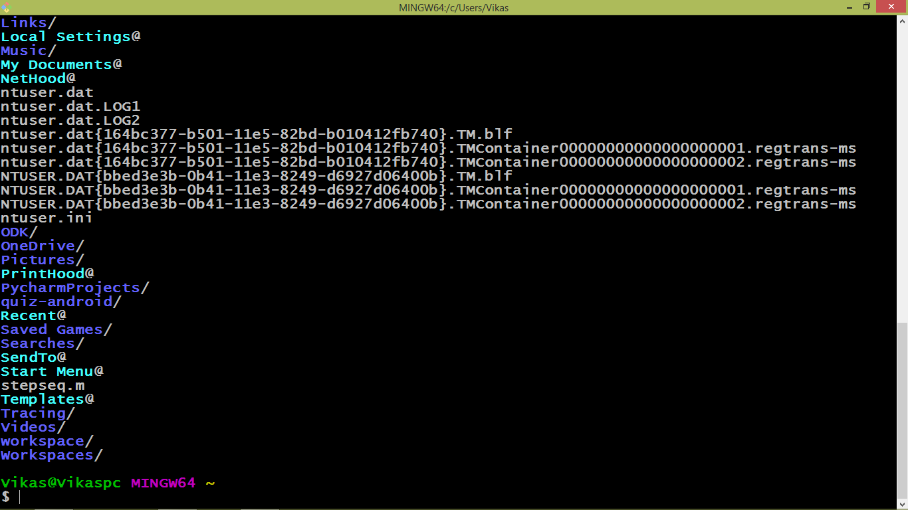
Now type we will go to ODK Directory(Folder)
Type cd ODK in the git bash

After that we will now create a repository of 3 things under that ODK Directory(Folder)
1).Gradle- Config
Type git clone https://github.com/opendatakit/gradle-config in the git bash
It will create a repository from the github
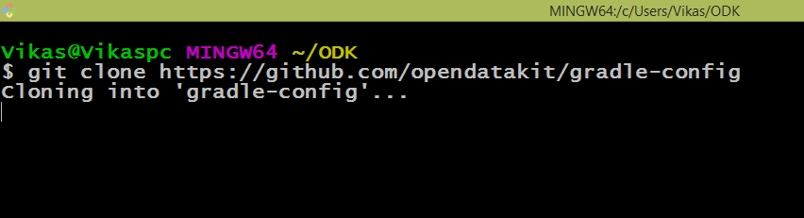

After cloning is done it will look like this
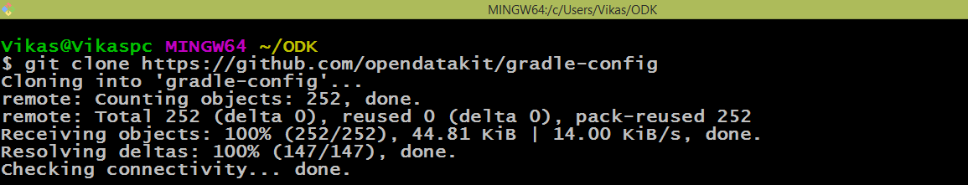

Now you type ls command in the git bash you will see gradle config/ Directory(Folder) inside the ODK Directory
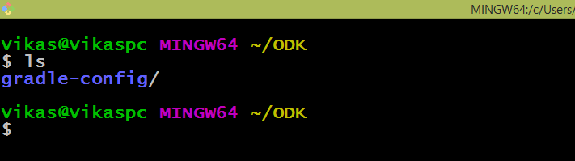
Now type “git clone https://github.com/opendatakit/google-play-services” inside the ODK Directory(Folder) it will clone the google play services from Github
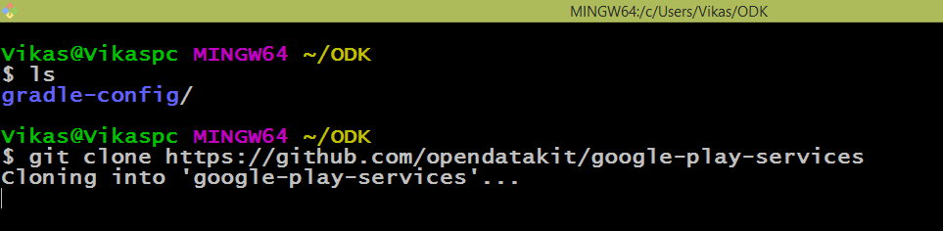
After downloading google play services directory will be created inside the ODK folder
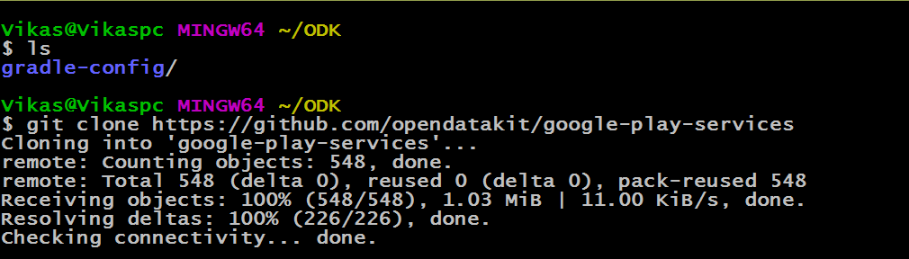
Type ls command in the git bash now we are having 2 directories
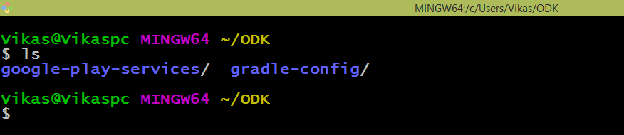

Now Type “git clone https://github.com/opendatakit/collect” to clone collect app under the ODK directory
It will take some time to download the collect app depending upon the speed of your wifi
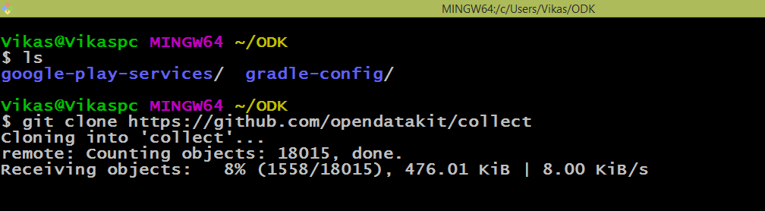
After cloning all 3 directories your ODK directory should look like this

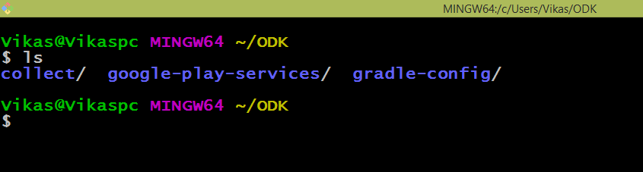
After cloning all the 3 Directories under ODK Directory now the gradle-config project should be checked out at the tag number declared at the top of the collect/settings.gradle file.
Type cd collect in the git bash this will take you under the collect directory
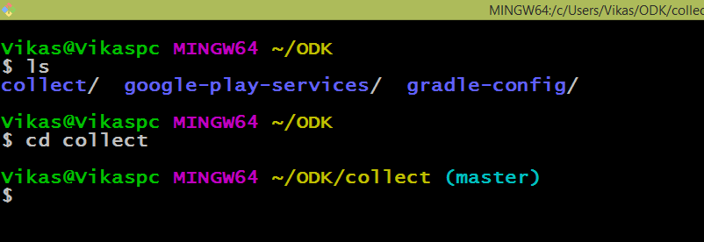
Under the collect directory
Now type “ls” command you will see all the contents of the collect directory
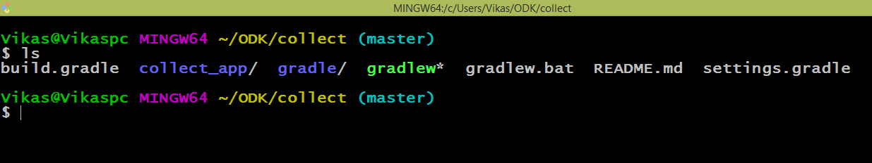
You will see there a settings.gradle file

Type “cat settings.gradle” command in the git bash you will see what is written in the file
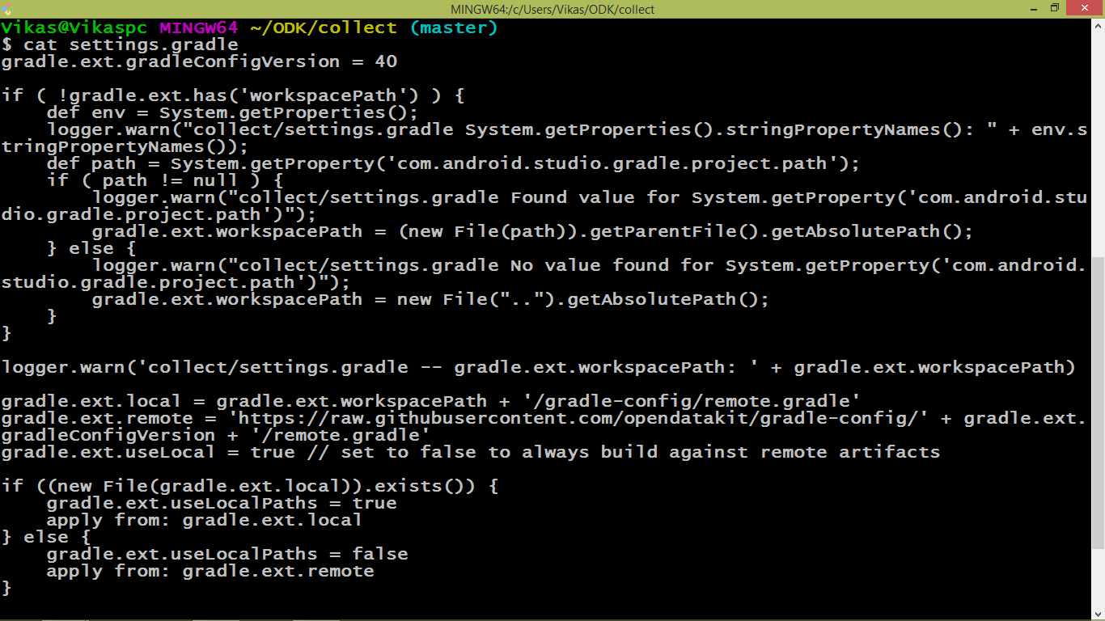
I the first line there is a tagname = 40 at the top of the file
Now type cd .. to come out of the Collect Directory
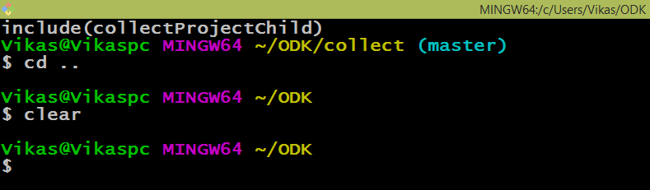
Now type “cd gradle-config/” command to go to gradle-config directory
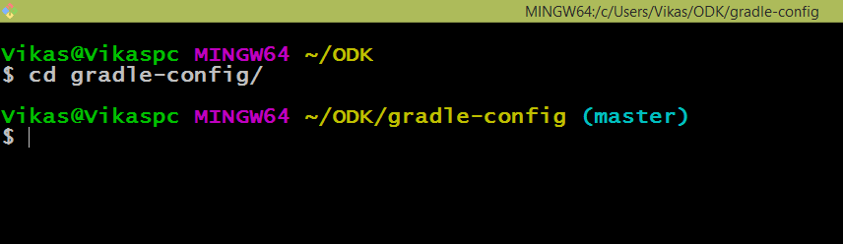

Now type “git checkout tags/40” in the git bash 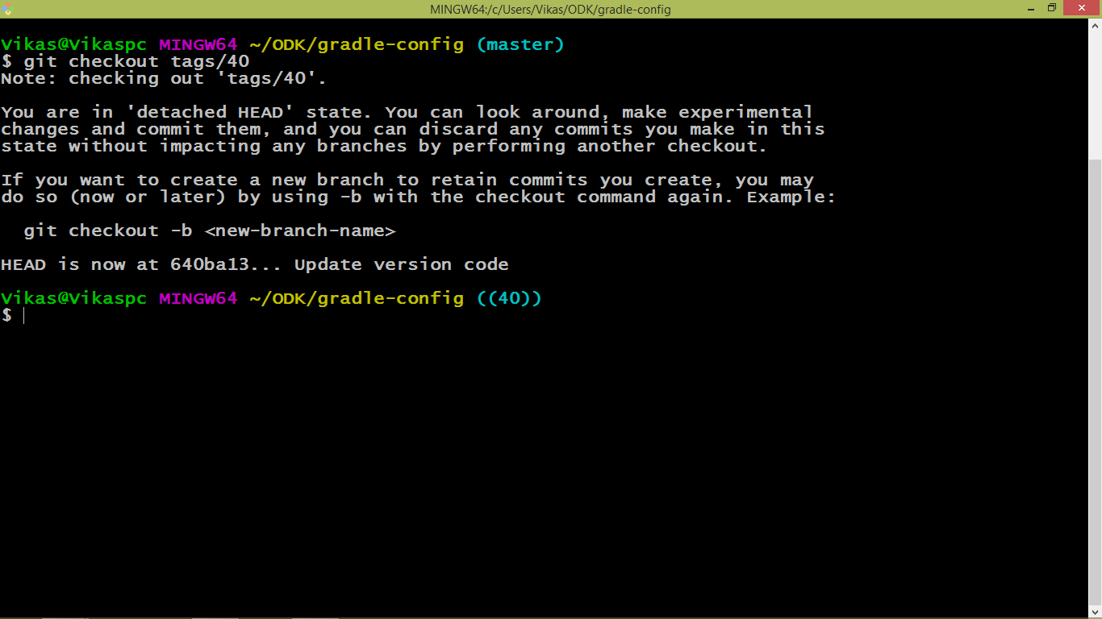

Now type “cd ..” to come out of gradle-config directory
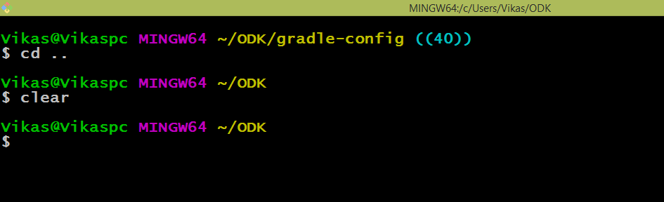
The google-play-services project should be pulled and at the tip.
It means latest version of google play services should be downloaded
Type “cd google-play-services/” in the git bash
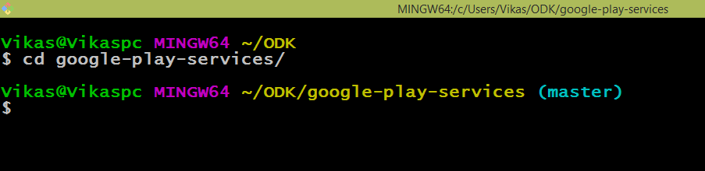
Type git pull command in the git bash
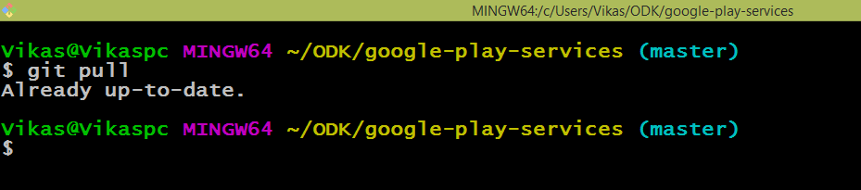
Then, import the collect/build.gradle file into Android Studio.
Open Android Studio go to file option then go to new then go to Project from version control and then go to Git
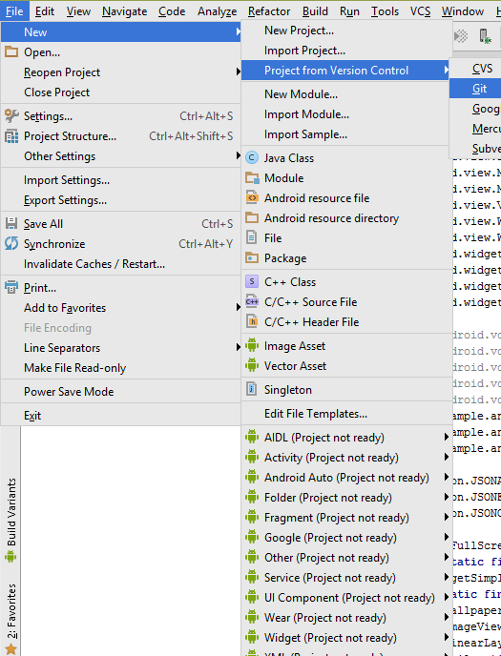
Now you will get this type of screen
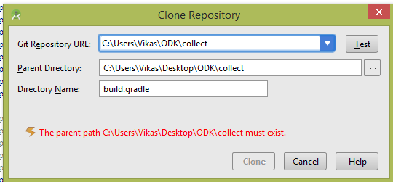
I have already cloned it so that is why I am getting this error else it would be fine with you
Note – while importing this project you must be connected to net
After that Gradle 2.10 zip file will be downloaded and after that gradle will be built
But after that I am getting this error
