History

Open Data Kit (ODK) is an open-source suite of tools that helps organizations author, field, and manage mobile data collection solutions. Our goals are to make open-source and standards-based tools which are easy to try, easy to use, easy to modify and easy to scale. To this end, we are proud members of the OpenRosa Consortium and active participants in the JavaRosa project.

ODK's core developers are researchers at the University of Washington's Department of Computer Science and Engineering department and active members of Change, a multi-disciplinary group at UW exploring how technology can improve the lives of under-served populations around the world.

ODK began as a google.org sponsored sabbatical project under the direction of Gaetano Borriello in April of 2008 at Google's Seattle offices. The initial team included Bill Schilit of Google Research, Adam Lerer of MIT (as a Google intern), and Julie Chin of Google.org. UW CSE graduate students Carl Hartung, Yaw Anokwa, and Waylon Brunette joined the team soon thereafter (as Google interns) and were responsible for the first two deployments of the tools in Uganda and Brazil.

Gaetano, Carl, Yaw and Waylon brought ODK back to UW in September of 2009 and Mitchell Sundt joined the team as a software engineer in 2010. Clarice Larson joined the team as a software engineer in 2013, and Jeff Beorse returned as a software engineer in 2015. Richard Anderson has led ODK since Gaetano passed away in early 2015. Other contributors at UW include Brian DeRenzi, Rohit Chaudhri, Nicola Dell, and numerous undergraduates. See our team page for a full list of participants.

ODK has been funded by a Google Focused Research Award and through donations from users. ODK is supported by a growing community of developers, implementers and users.

Vision

Open Data Kit (ODK) is a free and open-source set of tools which help organizations author, field, and manage mobile data collection solutions. ODK provides an out-of-the-box solution for users to:
- Build a data collection form or survey (XLSForm is recommended for larger forms);
- Collect the data on a mobile device and send it to a server; and
- Aggregate the collected data on a server and extract it in useful formats.

In addition to socio-economic and health surveys with GPS locations and images, ODK is being used to create decision support for clinicians and for building multimedia-rich nature mapping tools. See the list available tools, featured deployments, and implementation companies for more examples of what the ODK community is doing.
We welcome and encourage participation from the user community. ODK is supported by a growing community of developers, implementers and users as well as various companies. Core ODK development is supported by ongoing research at the University of Washington's Department of Computer Science & Engineering and through donationsfrom users.

Brief Overview of ODK (from user’s point of view)

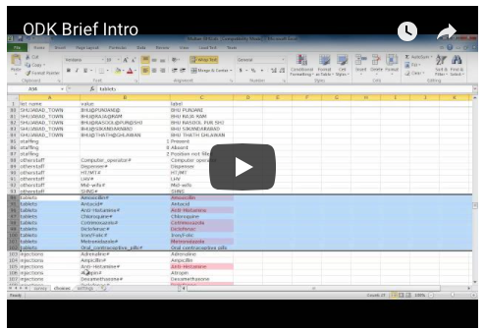

Brief Overview of ODK (from software developer’s point of view)

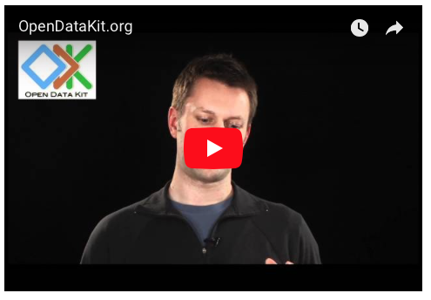

Team

Here are countless folks who made ODK what it is. Below are the people who have gone above and beyond.

Core Development Team
Gaetano Borriello (1959-2015), Richard Anderson, Waylon Brunette, Clarice Larson, Mitch Sundt, Jeff Beorse

Core Development Team Alumni
Yaw Anokwa (Nafundi), Nathan Breit, Rohit Chaudhri, Nicola Dell, Carl Hartung (Nafundi), Adam Lerer (D. E. Shaw Research)

Significant Code Contributors
Meletis Margaritis (SurveyCTO), Dylan Price, Sam Sudar, Clint Tseng (Socrata), Hilary Worden

Code Contributors
Ryan Atherton, Jeff Beorse, Brian DeRenzi, Anton DeWinter (Dimagi), Alex Dorey (Modi Research Group), Neil Hendrick (Harvard Humanitarian Initiative), Harlan Hile (Google), YoonSung Hong, Daniel Kayiwa (OpenMRS), Andrew Marder (Modi Research Group), Sam Mbuga (Mindflow Systems), Chris Robert (SurveyCTO), Drew Roos (Dimagi), Clayton Sims (Dimagi)

Code Patches, Documentation, Translation, and Other Contributions
Sean Askay (Google), Andrius Balsevicius, Curtis Broderick, Julie Chin (Google), Sunil Garg, Francesc Garre, James Hu, Mark Ivey (Google), Owen Kim, Jessica Leung, Moon Hwan Oh, Will Pitts, Tran Hong Quang(HSPH), Soyong Shin, Euzel Villanueva, Jimmy Zhang

If we forgot to add you, we are very sorry about the oversight. Please email contact@opendatakit.org.

Research

Open Data Kit is a research platform for the Department of Computer Science & Engineering at the University of Washington. We disseminate our work through academic as well as the popular press.

Below you will find a collection of publications about the ODK project.

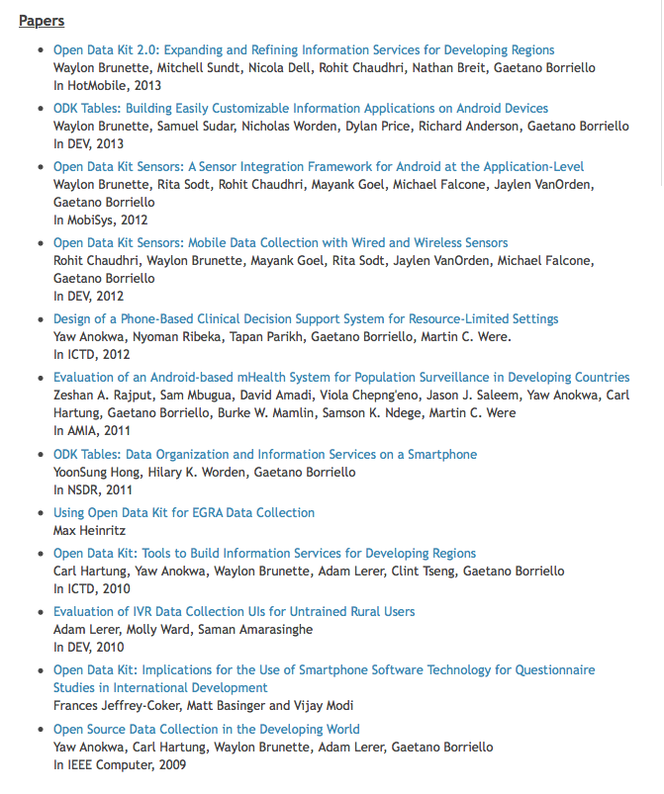

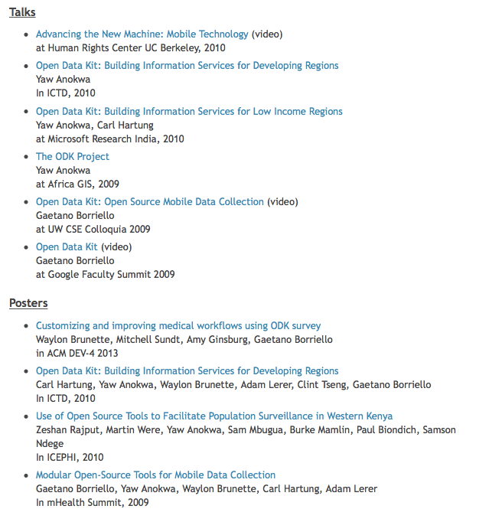

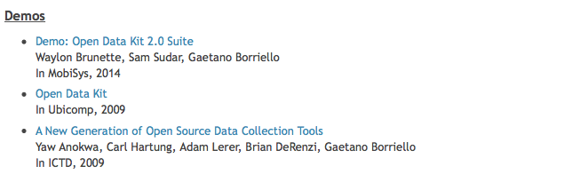

Press

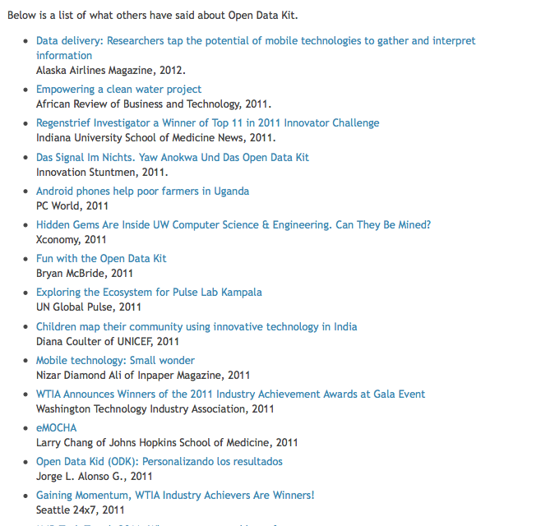

Security and Privacy

