While compiling xls forms to XML forms below error appear.

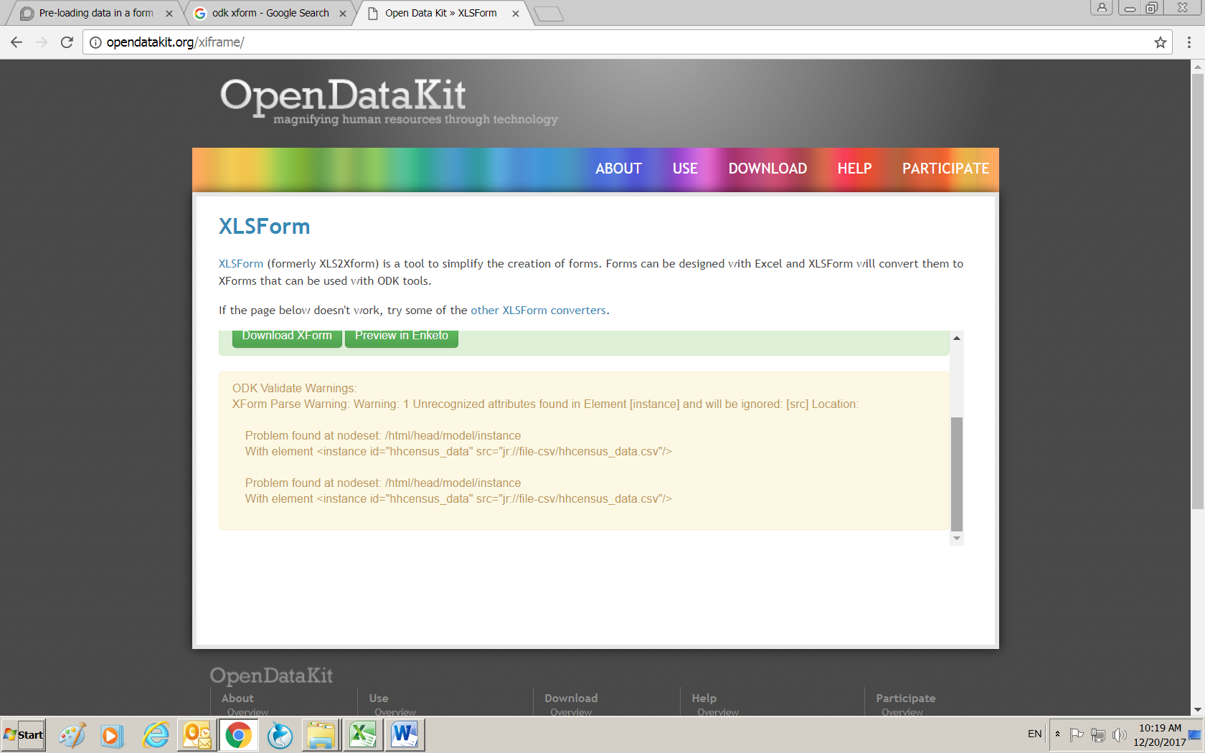

When I click on Preview Enketo below error appear.

Further, when I ignore the error and go further I will see the form but value which is supposed to bring from the csv file is blank. Please see the below screen shot

Enketo Preview form:

