Open Data Kit 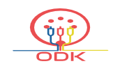
magnifying human resources through technology

Welcome to Open Data Kit. ODK is a free and open–source set of tools that creates forms, collects data and aggregates data. Whether you chase rhinos in the wild, plant seedlings in the deep rainforest or ensure vaccines are supplied to remote clinics, ODK can help document and organize your information.

About How I Use ODK Downloads

Learn How to Help Blog

About | How I Use ODK | Downloads | Learn | How to Help | Blog

English | Francais | عربى | Other

