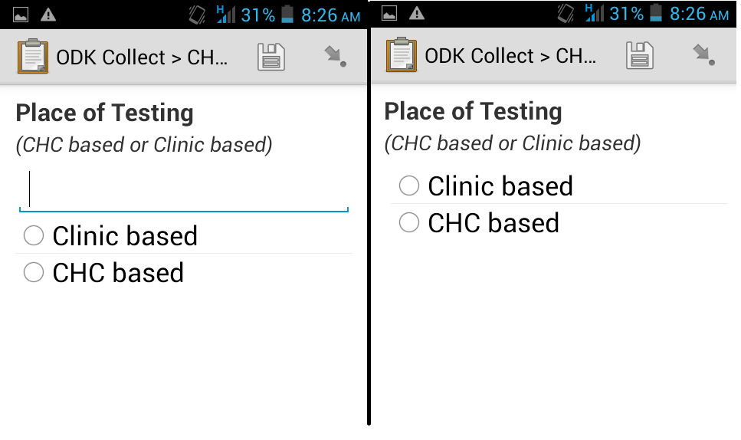

Earlier Version no line, same xml files nothing changed except updating to ODK

Version 1.4.10. This line