Errors

1. Username not found: zzxsm

2.username not found: zzx

3. Error posting to URL……401 unauthorized, must authenticate first
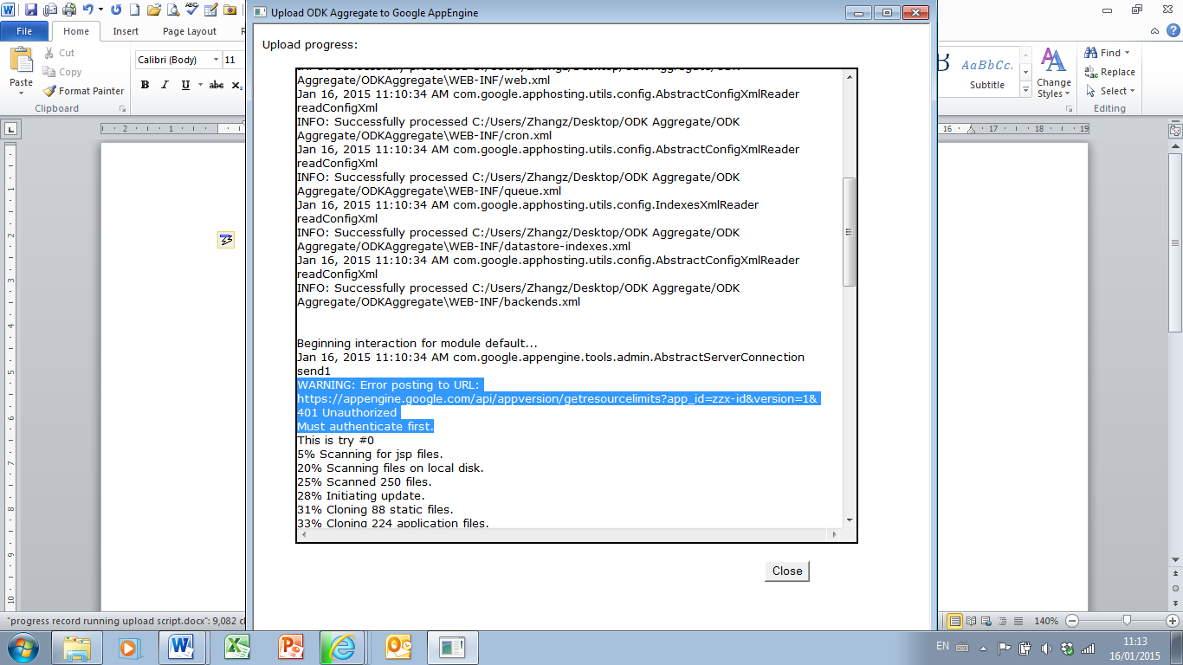

4. Empty folder “ODK aggregate”
