Contents:
Contents
1. Running process before clearing email protection: 1
2. Running progress record after clearing email protection 4
3. Interface coming up by clicking the “Log obit Aggregate” 6
4. Interface after clicking on “Sign in with Google” 7
5. Interface after clicking the “Anonymous access”. 7
6. Interface after clicking the “Sign in with Aggregate password” 8

Running process before clearing email protection:
Upload progress:
Looking for java...
found java in PATH... C:\ProgramData\Oracle\Java\javapath\java.exe
********************************************************
There is a new version of the SDK available.
-----------
Latest SDK:
Release: 1.9.15
Timestamp: Wed Oct 22 09:33:59 CST 2014
API versions: [1.0]
-----------
Your SDK:
Release: 1.9.7
Timestamp: Tue Jul 01 12:13:37 CST 2014
API versions: [1.0]
-----------
Please visit https://developers.google.com/appengine/downloads for the latest SDK.
********************************************************
Reading application configuration data...
Jan 15, 2015 8:59:21 AM com.google.apphosting.utils.config.AppEngineWebXmlReader readAppEngineWebXml
INFO: Successfully processed C:/Users/Zhangz/Desktop/ODK/ODK Aggregate/ODKAggregate\WEB-INF/appengine-web.xml
Jan 15, 2015 8:59:22 AM com.google.apphosting.utils.config.AbstractConfigXmlReader readConfigXml
INFO: Successfully processed C:/Users/Zhangz/Desktop/ODK/ODK Aggregate/ODKAggregate\WEB-INF/web.xml
Jan 15, 2015 8:59:22 AM com.google.apphosting.utils.config.AbstractConfigXmlReader readConfigXml
INFO: Successfully processed C:/Users/Zhangz/Desktop/ODK/ODK Aggregate/ODKAggregate\WEB-INF/cron.xml
Jan 15, 2015 8:59:22 AM com.google.apphosting.utils.config.AbstractConfigXmlReader readConfigXml
INFO: Successfully processed C:/Users/Zhangz/Desktop/ODK/ODK Aggregate/ODKAggregate\WEB-INF/queue.xml
Jan 15, 2015 8:59:22 AM com.google.apphosting.utils.config.IndexesXmlReader readConfigXml
INFO: Successfully processed C:/Users/Zhangz/Desktop/ODK/ODK Aggregate/ODKAggregate\WEB-INF/datastore-indexes.xml
Jan 15, 2015 8:59:22 AM com.google.apphosting.utils.config.AbstractConfigXmlReader readConfigXml
INFO: Successfully processed C:/Users/Zhangz/Desktop/ODK/ODK Aggregate/ODKAggregate\WEB-INF/backends.xml
Beginning interaction for module default...
Jan 15, 2015 8:59:24 AM com.google.appengine.tools.admin.AbstractServerConnection send1
WARNING: Error posting to URL: https://appengine.google.com/api/appversion/getresourcelimits?app_id=zzx-id&version=1&
401 Unauthorized
Must authenticate first.
This is try #0
5% Scanning for jsp files.
20% Scanning files on local disk.
25% Scanned 250 files.
28% Initiating update.
31% Cloning 88 static files.
33% Cloning 224 application files.
40% Uploading 1 files.
52% Uploaded 1 files.
61% Uploading 2 file(s) for static error handlers.
68% Initializing precompilation...
73% Sending batch containing 1 file(s) totaling 5KB.
90% Deploying new version.
95% Closing update: new version is ready to start serving.
98% Uploading index definitions.
99% Uploading cron jobs.
99% Uploading task queues.
Update for module default completed successfully.
Success.
Cleaning up temporary files for module default...
---- WEBSITE COMPLETE - BEGIN BACKEND ----
Reading application configuration data...
Jan 15, 2015 9:00:41 AM com.google.apphosting.utils.config.AppEngineWebXmlReader readAppEngineWebXml
INFO: Successfully processed C:/Users/Zhangz/Desktop/ODK/ODK Aggregate/ODKAggregate\WEB-INF/appengine-web.xml
Jan 15, 2015 9:00:41 AM com.google.apphosting.utils.config.AbstractConfigXmlReader readConfigXml
INFO: Successfully processed C:/Users/Zhangz/Desktop/ODK/ODK Aggregate/ODKAggregate\WEB-INF/web.xml
Jan 15, 2015 9:00:41 AM com.google.apphosting.utils.config.AbstractConfigXmlReader readConfigXml
INFO: Successfully processed C:/Users/Zhangz/Desktop/ODK/ODK Aggregate/ODKAggregate\WEB-INF/cron.xml
Jan 15, 2015 9:00:41 AM com.google.apphosting.utils.config.AbstractConfigXmlReader readConfigXml
INFO: Successfully processed C:/Users/Zhangz/Desktop/ODK/ODK Aggregate/ODKAggregate\WEB-INF/queue.xml
Jan 15, 2015 9:00:41 AM com.google.apphosting.utils.config.IndexesXmlReader readConfigXml
INFO: Successfully processed C:/Users/Zhangz/Desktop/ODK/ODK Aggregate/ODKAggregate\WEB-INF/datastore-indexes.xml
Jan 15, 2015 9:00:41 AM com.google.apphosting.utils.config.AbstractConfigXmlReader readConfigXml
INFO: Successfully processed C:/Users/Zhangz/Desktop/ODK/ODK Aggregate/ODKAggregate\WEB-INF/backends.xml
Beginning interaction for module default...
Warning: This application uses Backends, a deprecated feature that has been replaced by Modules, which offers additional functionality. Please convert your backends to modules as described at: https://developers.google.com/appengine/docs/java/modules/converting.
0% Created staging directory at: 'C:\Users\Zhangz\AppData\Local\Temp\appcfg3333709763798205793.tmp'
5% Scanning for jsp files.
20% Scanning files on local disk.
25% Scanned 250 files.
28% Initiating update of backend background.
31% Cloning 88 static files.
33% Cloning 224 application files.
40% Uploading 0 files.
52% Uploading 2 file(s) for static error handlers.
61% Initializing precompilation...
90% Deploying new version.
95% Closing update: new version is ready to start serving.
98% Uploading index definitions.
99% Uploading cron jobs.
99% Uploading task queues.
Update completed successfully.
Success.
Cleaning up temporary files for module default...
---END-SCRIPT-SUCCESS---

Running progress record after clearing email protection
Upload progress:
Looking for java...
found java in PATH... C:\ProgramData\Oracle\Java\javapath\java.exe
********************************************************
There is a new version of the SDK available.
-----------
Latest SDK:
Release: 1.9.15
Timestamp: Wed Oct 22 09:33:59 CST 2014
API versions: [1.0]
-----------
Your SDK:
Release: 1.9.7
Timestamp: Tue Jul 01 12:13:37 CST 2014
API versions: [1.0]
-----------
Please visit https://developers.google.com/appengine/downloads for the latest SDK.
********************************************************
Reading application configuration data...
Jan 15, 2015 9:36:58 AM com.google.apphosting.utils.config.AppEngineWebXmlReader readAppEngineWebXml
INFO: Successfully processed C:/Users/Zhangz/Desktop/ODK Aggregate/ODKAggregate\WEB-INF/appengine-web.xml
Jan 15, 2015 9:36:58 AM com.google.apphosting.utils.config.AbstractConfigXmlReader readConfigXml
INFO: Successfully processed C:/Users/Zhangz/Desktop/ODK Aggregate/ODKAggregate\WEB-INF/web.xml
Jan 15, 2015 9:36:58 AM com.google.apphosting.utils.config.AbstractConfigXmlReader readConfigXml
INFO: Successfully processed C:/Users/Zhangz/Desktop/ODK Aggregate/ODKAggregate\WEB-INF/cron.xml
Jan 15, 2015 9:36:58 AM com.google.apphosting.utils.config.AbstractConfigXmlReader readConfigXml
INFO: Successfully processed C:/Users/Zhangz/Desktop/ODK Aggregate/ODKAggregate\WEB-INF/queue.xml
Jan 15, 2015 9:36:58 AM com.google.apphosting.utils.config.IndexesXmlReader readConfigXml
INFO: Successfully processed C:/Users/Zhangz/Desktop/ODK Aggregate/ODKAggregate\WEB-INF/datastore-indexes.xml
Jan 15, 2015 9:36:58 AM com.google.apphosting.utils.config.AbstractConfigXmlReader readConfigXml
INFO: Successfully processed C:/Users/Zhangz/Desktop/ODK Aggregate/ODKAggregate\WEB-INF/backends.xml
Beginning interaction for module default...
0% Created staging directory at: 'C:\Users\Zhangz\AppData\Local\Temp\appcfg8702683545326403607.tmp'
5% Scanning for jsp files.
20% Scanning files on local disk.
25% Scanned 250 files.
28% Initiating update.
31% Cloning 88 static files.
33% Cloning 224 application files.
40% Uploading 1 files.
52% Uploaded 1 files.
61% Uploading 2 file(s) for static error handlers.
68% Initializing precompilation...
73% Sending batch containing 1 file(s) totaling 5KB.
90% Deploying new version.
95% Closing update: new version is ready to start serving.
98% Uploading index definitions.
99% Uploading cron jobs.
99% Uploading task queues.
Update for module default completed successfully.
Success.
Cleaning up temporary files for module default...
---- WEBSITE COMPLETE - BEGIN BACKEND ----
Reading application configuration data...
Jan 15, 2015 9:37:49 AM com.google.apphosting.utils.config.AppEngineWebXmlReader readAppEngineWebXml
INFO: Successfully processed C:/Users/Zhangz/Desktop/ODK Aggregate/ODKAggregate\WEB-INF/appengine-web.xml
Jan 15, 2015 9:37:49 AM com.google.apphosting.utils.config.AbstractConfigXmlReader readConfigXml
INFO: Successfully processed C:/Users/Zhangz/Desktop/ODK Aggregate/ODKAggregate\WEB-INF/web.xml
Jan 15, 2015 9:37:49 AM com.google.apphosting.utils.config.AbstractConfigXmlReader readConfigXml
INFO: Successfully processed C:/Users/Zhangz/Desktop/ODK Aggregate/ODKAggregate\WEB-INF/cron.xml
Jan 15, 2015 9:37:49 AM com.google.apphosting.utils.config.AbstractConfigXmlReader readConfigXml
INFO: Successfully processed C:/Users/Zhangz/Desktop/ODK Aggregate/ODKAggregate\WEB-INF/queue.xml
Jan 15, 2015 9:37:49 AM com.google.apphosting.utils.config.IndexesXmlReader readConfigXml
INFO: Successfully processed C:/Users/Zhangz/Desktop/ODK Aggregate/ODKAggregate\WEB-INF/datastore-indexes.xml
Jan 15, 2015 9:37:49 AM com.google.apphosting.utils.config.AbstractConfigXmlReader readConfigXml
INFO: Successfully processed C:/Users/Zhangz/Desktop/ODK Aggregate/ODKAggregate\WEB-INF/backends.xml
Beginning interaction for module default...
Warning: This application uses Backends, a deprecated feature that has been replaced by Modules, which offers additional functionality. Please convert your backends to modules as described at: https://developers.google.com/appengine/docs/java/modules/converting.
0% Created staging directory at: 'C:\Users\Zhangz\AppData\Local\Temp\appcfg6163544521282212503.tmp'
5% Scanning for jsp files.
20% Scanning files on local disk.
25% Scanned 250 files.
28% Initiating update of backend background.
31% Cloning 88 static files.
33% Cloning 224 application files.
40% Uploading 0 files.
52% Uploading 2 file(s) for static error handlers.
61% Initializing precompilation...
90% Deploying new version.
95% Closing update: new version is ready to start serving.
98% Uploading index definitions.
99% Uploading cron jobs.
99% Uploading task queues.
Update completed successfully.
Success.
Cleaning up temporary files for module default...
---END-SCRIPT-SUCCESS---

Interface coming up by clicking the “Log obit Aggregate”

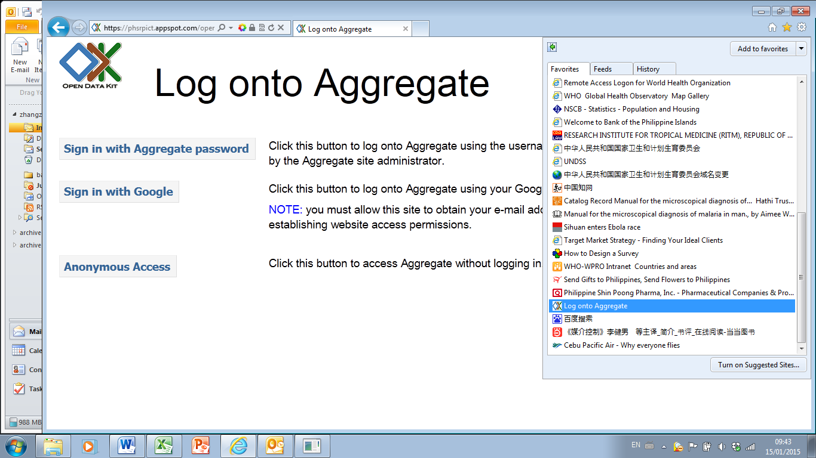

Interface after clicking on “Sign in with Google”
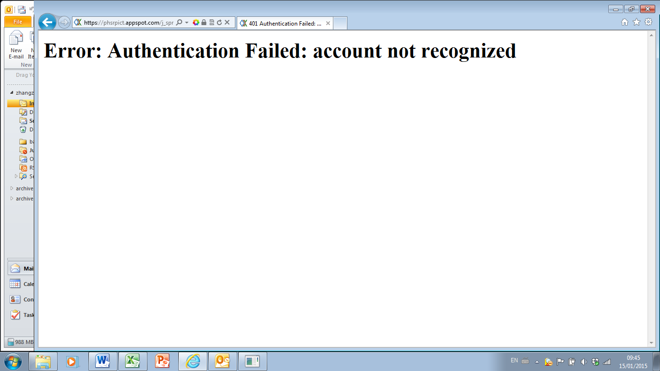

Interface after clicking the “Anonymous access”.
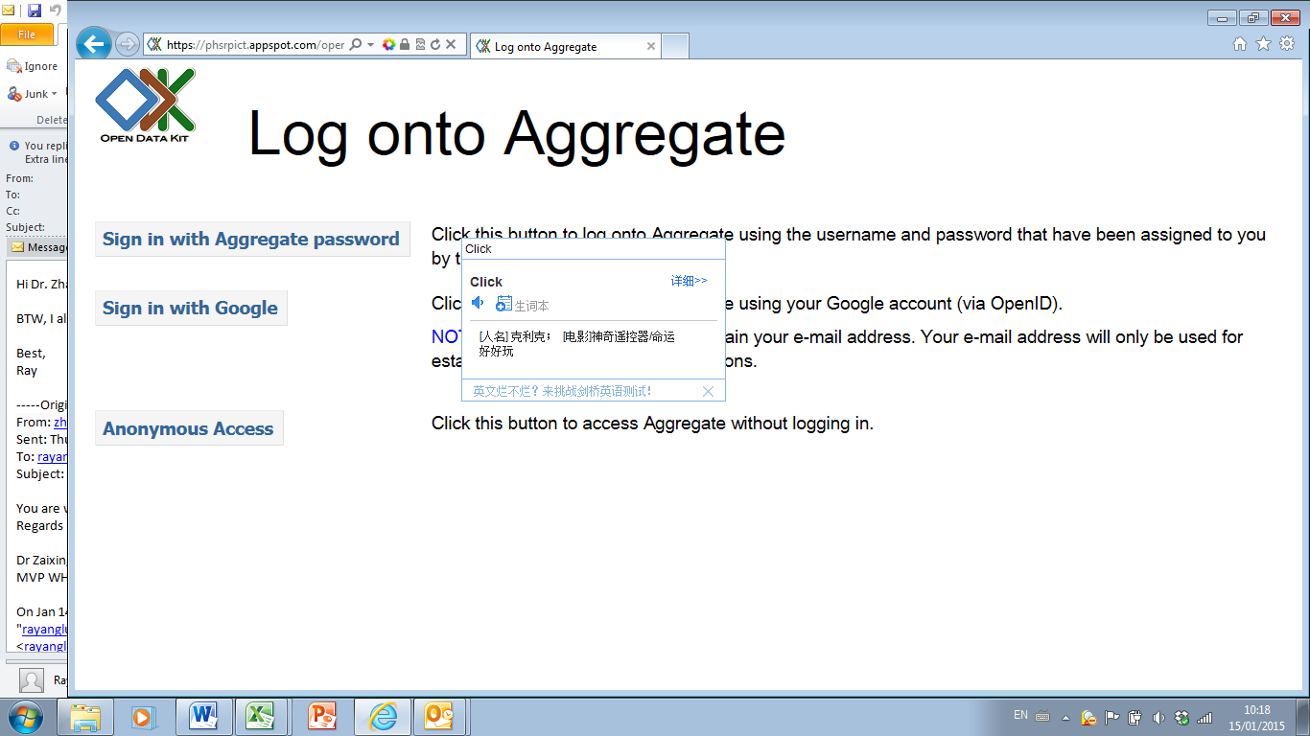

Interface after clicking the “Sign in with Aggregate password”
