Hello,

We are pursuing an ODK implementation for a potential client. The implementation requires capturing attendance for a group of 15-20 participants who attend frequent classes at training centers located in rural or semi-urban areas in India with minimal or no internet connectivity.

We hope to develop a functionality that would allow our field staff to fill the attendance form with participant names at the initial class meeting and then clone this form multiple times, saving it to their mobile device. They would then be able to capture and save attendance data on these previously cloned forms.

Below is the requirement:

1. User fills the form using the **Fill Blank Form** button and saves the form
2. User Clicks on **Edit Saved Form** (Figure 1)button to get the list of filled forms.
3. Checkboxes (Figure 2) should be available for the User to select forms that needs to be cloned.
4. User Clicks on **Clone Selected** button to clone the selected forms (Figure 3).
5. User should then be able to **Sync** any of these forms with the server (as part of standard ODK functionality).

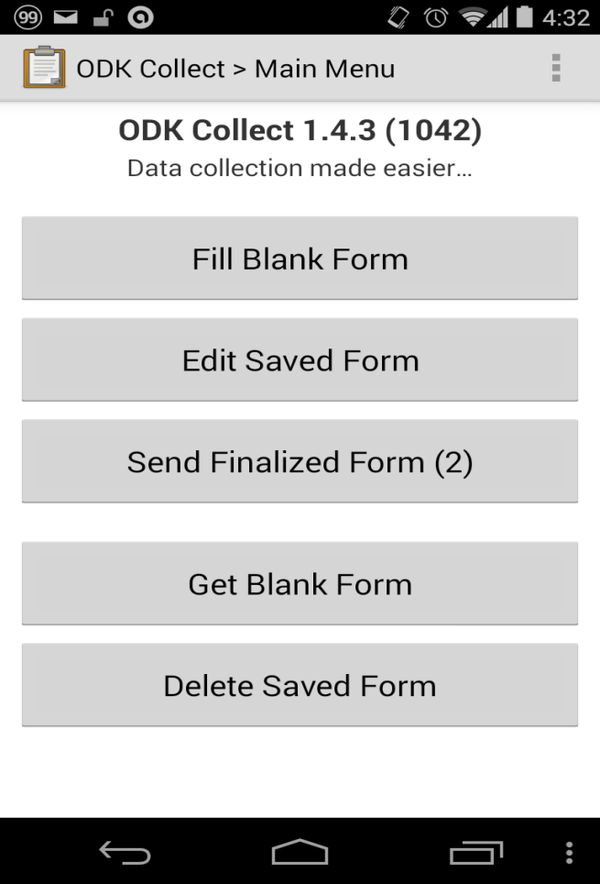 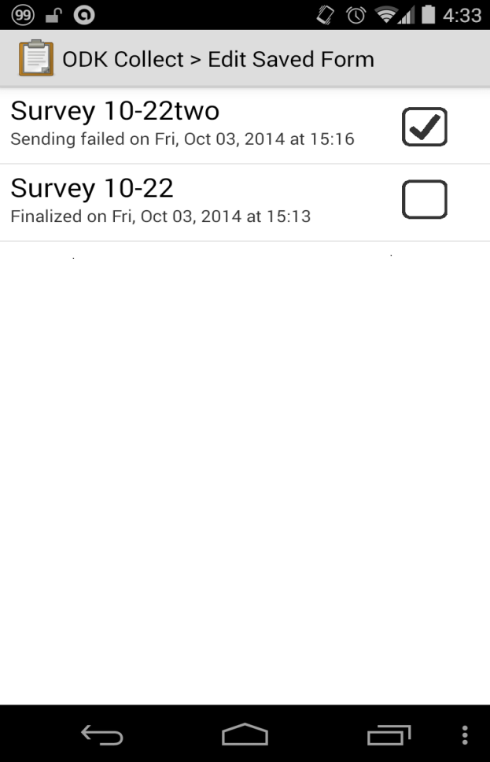

Figure 1 Figure 2

Clone Selected

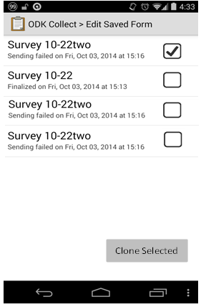

Figure 3

Is this undertaking achievable? If yes, can you provide us with a time and effort estimate? If not, what are the factors that would prevent the development of this functionality?