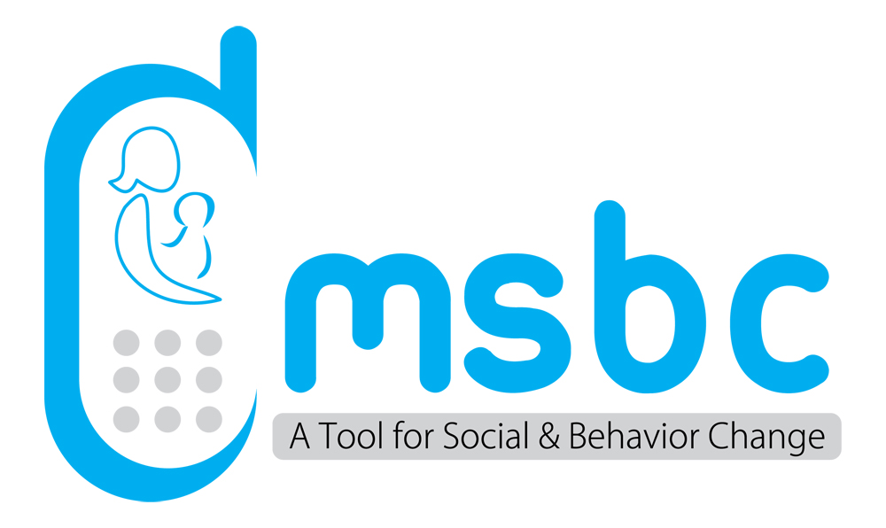
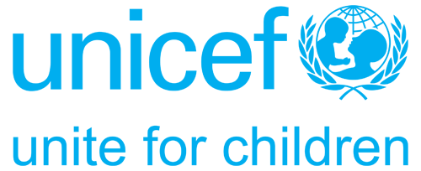
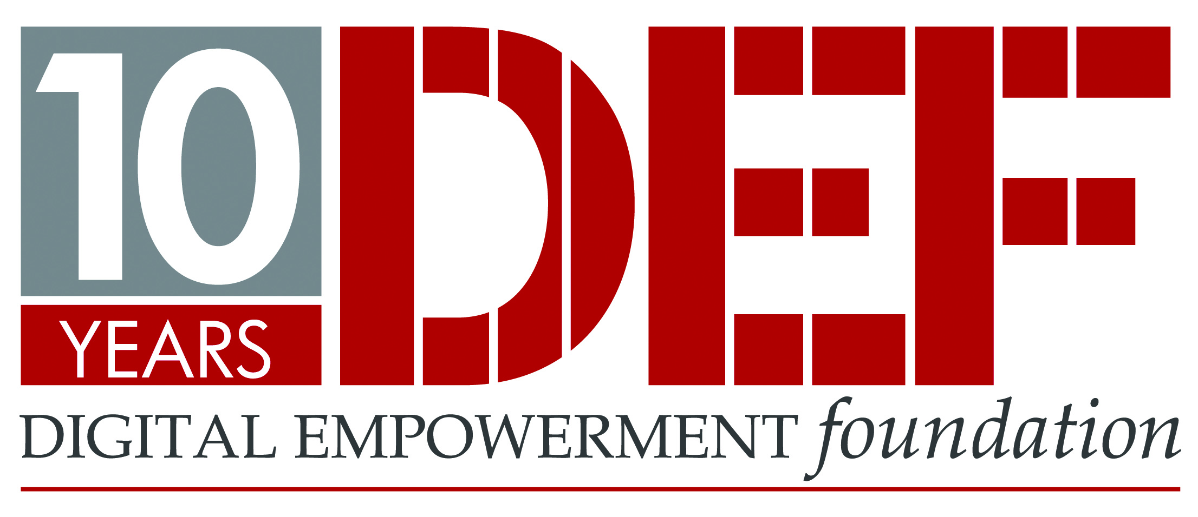

Application Form
MSBC: CALL FOR EXPERIENCES; PRACTICES & CASE-STUDIES
Send your filled application form to: msbcindia.org@gmail.com
*All fields and mandatory.
*Project video/PPT can be accepted through web-link or mail attachment

Details of the Applicant
Name
Designation
Organization
Address
City
State:
Country
Organization Website
Details of the Agency implemented the project/programme
Name of the Organization
Address
City
State
Head of Organization
Language (s) of the Initiative
Project Website
Details of the Case-study/Project/Practice
Specify the state where your project has been running (mark a tick ) | - Madhya Pradesh [ ]  - Uttar Pradesh [ ]  - Andhra Pradesh [ ]  - Tamil Nadu [ ]  - Assam [ ]  - Any other; please specify ………………
Which of these genres does your mobile project cover (mark a tick ) | - Education [ ]  - Health [ ]  - Disaster management [ ]  - Environment protection / sustainability [ ]  - Women & child empowerment [ ]
With respect to the above categories, how is your mobile project intervening (mark a tick ) | - Information dissemination [ ]  - Training purpose [ ]  - Monitoring & tracking purpose [ ]  - Inter personal communication purpose [ ]
Brief description about the practice/case-study/project [word limit: 200]
What are the objectives of the practice/case-study/project? [Word limit: 200 words]
How have you used project for information & dissemination? Highlight the number of beneficiaries in terms of women, children, others.
How have you used project for training & capacity building of front line workers? Highlight the number of beneficiaries in terms of women, children, others.
How have you used project for enhancing interpersonal communications skills of front line workers? Highlight the number of beneficiaries in terms of women, children, others.
How does the practice/project engage women in terms of utilizing mobile-based services (IVR, SMS, Text Messages, Listening Music, Entertainment, etc?)
What kind of special content and services have you developed for the benefit of women, children and adolescents in your project? [Word limit: 200 words]
Give a ballpark figure of how many women, adolescent, children and youth use your services in your area?
In what ways has the usage of your mobile service brought in a behavioral change amongst women, children and young people and who are using mobile in your community and network? Please list at least 10 behavioral changes
Keeping in view the following areas can you specify the changes that have you observed among the women/young people who are using your mobile service? | In confidence (behavioural change)  In exercising freedom  In literacy  In getting their work done  In getting more work  In saving time and money to get information
According to you, what are the social benefits of mobile usage by women, adolescent girls and youth? Identify minimum 5 benefits.
What are the social disadvantages that have been observed because of the usage of mobiles by women and young people in the community? Can you list with explanation some of them?
List a minimum of please list at least 10-15 points on as to how the mobile phones can be great empowering tool for to empower women, children, adolescents groups and others in areas of education, health, disaster and disaster management/environment protection. What are the key steps key steps required?
Is your project/practice sustainable? If yes, then how? (Word limit: 200 words).
Can the model of your project, be replicated in other states of the country? If yes, how? (Word limit: 200 words).
Do you think if you withdraw your services, women and other targeted people in the area will stop using mobiles? [Word Limit: 200 words]
Any other additional resources/information (including project report, project video, project website, any award/recognition

