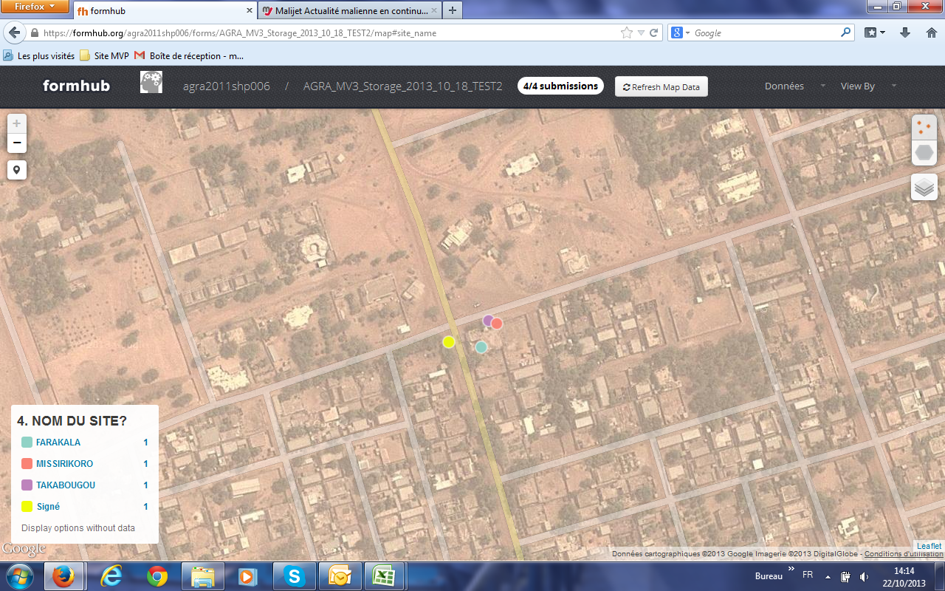

Plot 4

Plot 3

Plot 2

Plot 1